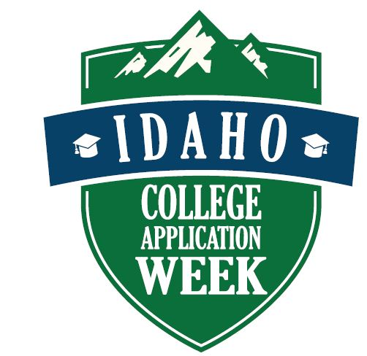
Our school/organization is participating in Idaho’s statewide College Application Week! To ensure that our event is a success for our students, we need your help in promoting and coordinating this event — and making sure our initiative is exciting and fun for our students, families, and community!

What is College Application Week?

An Overview for Teachers & Staff

College Application Week is an event coordinated by The Office of the State Board of Education. Idaho College Application Week will be held during November 6 10, 2017 in more than 80 high schools throughout Idaho. College Application Week has been successfully implemented in all 50 states and the District of Columbia.

What is the goal of College Application Week?

Our goal is to provide every graduating high school senior with the opportunity to apply to college. While much of the focus of College Application Week is geared toward first-generation college students, low-income students, and other students who face barriers to applying to college, we encourage all students, including freshmen, sophomores, and juniors, as well as seniors who have already applied to college, to participate in events to help them explore and prepare for postsecondary education, including certificate programs, two-year degrees, and four-year degrees.

What happens during College Application Week?

Think of College Application Week as a school spirit week, during which we all work together to build excitement and awareness surrounding the college exploration and application process. High Schools will provide computer lab time to students to allow them to explore colleges and apply online, but the event becomes truly spectacular when we integrate fun activities into our school and community environments. For example, we can decorate our doors and classrooms in college themes, post signs and pennants in our community, decorate storefronts, have college trivia contests — let’s get creative!

How can I help?

You can help by assisting students in applying, contributing to the “spirit” of the week, or — perhaps most importantly — reaching out to students to encourage them to apply to college. Seek out those students who might traditionally be overlooked when it comes to college planning, and talk to them about their options for college. Be sure to ask students if they’ve applied as they board the bus, go through the lunch line, or walk into church, a store, or your classroom.

