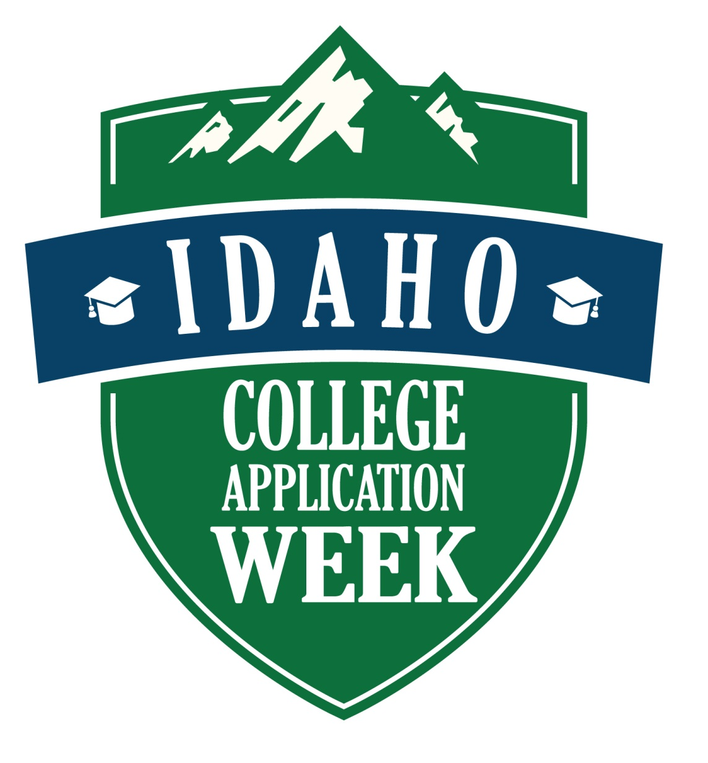

ASK ME WHERE
I WENT TO COLLEGE!

